**Hospital system**

**Aim:**

To create UML diagram for Railway Reservation System using umbrello tool.

**USE CASE DIAGRAM**

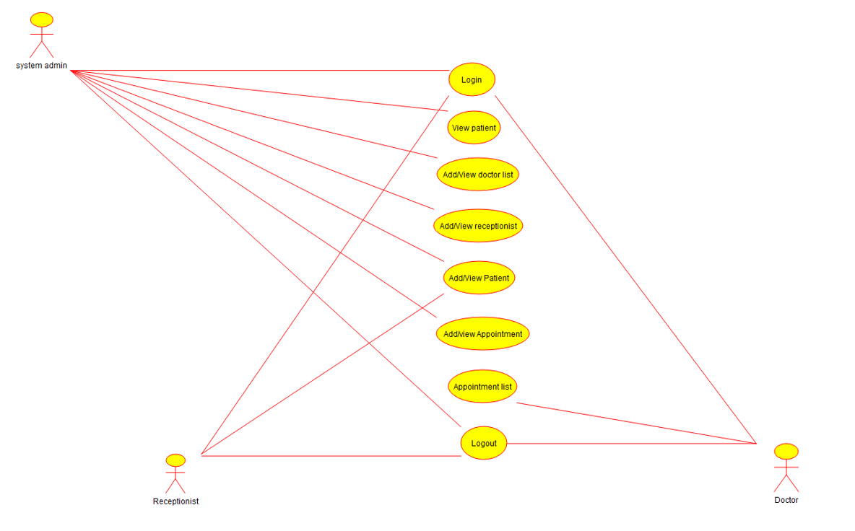

**ACTIVITY DIAGRAM**

